How to check your species base list against the MSBP Data Warehouse base list

Go to the MSBP Data Warehouse website http://brahmsonline.kew.org/msbp
Log in (see the log in button in the top right corner)
Go to Seed Data > Base lists – this menu option is only available after you have logged in
Download the MSBP Data Warehouse list base list of species, this is the base list in the top of the two tables. Save the list in a convenient folder.
Open your species target list and the MSBP base list.
Make sure genus and species are concatenated into a binomial species name in your target list, for example Acalypha caturus shown below. To do this click on the first empty cell to the right of the first entry in your list. Now type
=concatenate(B2,” “,C2)
(Where genus is in column B and species in column C, as shown in the screenshot below.)
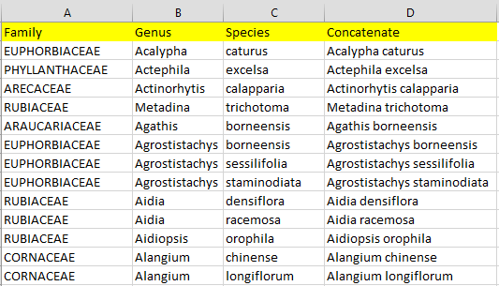
You should now paste the formula as values.
- Copy the whole of the concatenated column (column D in the example above), by left clicking on the column letter (D). The column is now highlighted in grey.
- Now right click anywhere inside that column, and select Copy
- Right click anywhere inside that column again, and select Paste Special, paste as values (the symbol is a clipboard with 123). The column contents are remain the same, but the concatenate formula has been replaced by static values.
Copy the Data Warehouse list into a separate tab within your species list.
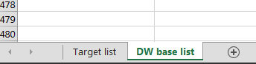
Back in the tab containing your Target list, in the first free column write a vlookup formula as shown below.
=vlookup(D2,'DW base list'!D:D,1,false)
(Where “D2” represent the cell containing the binomial species name, “'DW base list'!D:D” shows the tab and cells in which you are searching for a match,”1” means you take the results in the first column (in this example binomial species name), and “false” means you return only perfect matches - no fuzzy matches are permitted).
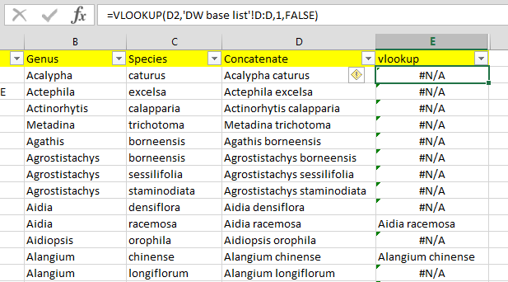
Where the binomial species name is populated you have a match; that means that species has already been collected by the MSBP partnership. Where #n/a is returned that means that at the current moment there is no recorded collection of that species by the MSBP network.
You may wish to put a “y” next to all the matched species (use filters to help you), and an “n” next to any that do not draw a match. You can then count the number of matches using the following formula
=COUNTIF(F:F,"y")
=COUNTIF(F:F,"n")
Where the column containing matches (“y”) and non-matches (“n”) is column F.
So in the example below 76 species have already been collected by the MSBP network, and 969 have not.
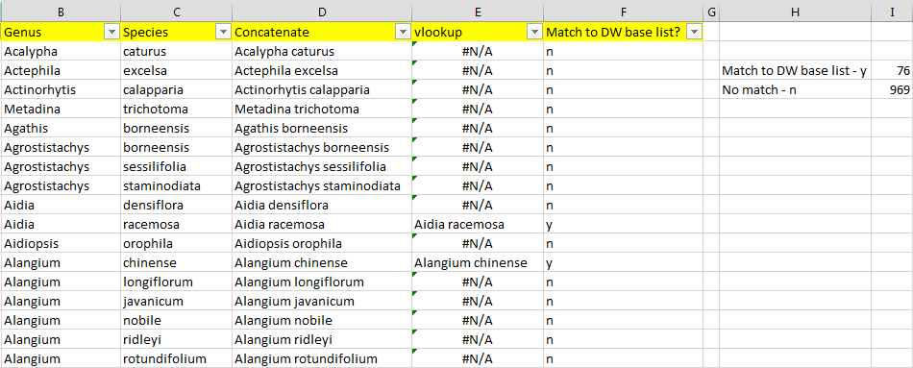

Help!
If you are struggling with any excel formula, you can use the function help button to open a tool to help you input the necessary information correctly.
Click on the fx button to the left of the formula bar
If the cell you are currently in is blank, the next screen will appear. Type in the function you want help with, for example VLOOKUP, make sure the correct function is highlighted in blue in the second box, then click OK.
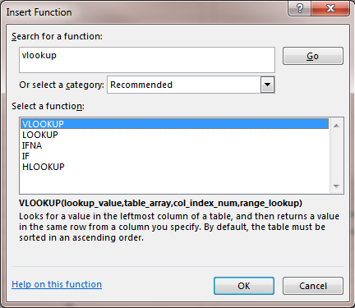
Next you will see this screen, (or if you clicked on cell which already contains the vlookup function you will jump straight here)
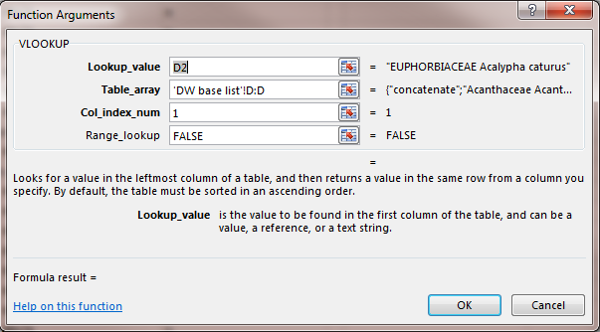
Fill in all the boxes according to the instructions and hopefully your function will now work.
You can also contact Naomi Carvey, the Data Warehouse Project Officer who is always very willing to help you FNC-MSBP Data Warehouse.

